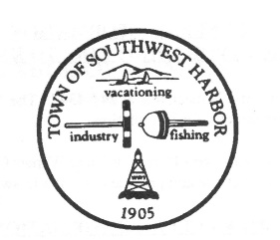
Warrant Committee Minutes

Southwest Harbor Wednesday January 27, 2021 @ 6:00 PM
via Zoom

I. Call to Order/Roll Call – Administrative Assistant Jesse Dunbar called the meeting to order at 6:02pm. Present were Warrant Committee members Lydia Goetze, Alan Rosenquist, Carl Wrubel, John Williams, Ellen Pope, Ruth Davis, Jim Vallette, Don Lodge, and Priscilla Ksionzyk.

II. Adoption of the Agenda – Adopted as written

III. Election of Officers:
Motion by Rosenquist to elect Lydia Goetze as Chair, Second by Ksionzyk. Goetze declined to be nominated as chair due to other commitments.

Motion by Goetze to elect Don Lodge as Chair, Second by Rosenquist. Passed 8-0-1 with Lodge abstaining.

Motion by Ksionzyk to elect Jim Vallette as Vice Chair, Second by Goetze. Passed 8-0-1 with Vallette abstaining.

Motion by Davis to elect Admin Assistant Jesse Dunbar as Secretary, Second by Goetze. Passed 9-0-0.

IV. Set Meeting Schedule – The deadline for returning the committee’s recommendations is March 10th, 2021. Lodge suggested the committee meet on Mondays. The Committee will begin February 1, 2021 with Community Service Organizations and the Admin side of the budget. Tentatively they have scheduled February 8, 2021 for Police and Fire and February 15, 2021 for Highway and Harbor.

V. Other Business – Discussion was had on how the budget is presented/ reviewed. Vallette brought up his concern that the Warrant Committee’s recommendations that differed from the Select Board’s was not published in the Warrant for FY21.

VI. Adjourn Meeting
Motion to adjourn at 6:57pm by Goetze, Second by Rosenquist. Passed 9-0-0.

